9NIGHT 10DAYS CHAR DHAM PACKAGE
EXPLORE GLOBAL
Email: globalexplore243@gmail.com
Web site: https://Exploreglobal.in
PhoneNumber:8352976379
Dear Sir/Madam,
Greetings from Explore Global !!!
We appreciate your query at Explore . We are here committed to make your holidays full of joy and hassle free indelible experience.
Tour Details
Trip to | Chardham Yatra
Pick up Point | Haridwar
Duration | 09N/10D
No of People | 04 Adults
No of Rooms | On Quad Sharing
Transportation | Ertiga/Similar
Validity of Quote | Till Availabilty
PACKAGE ITINERARY

DAY1-HARIDWAR to BARKOT
On arrival driver will pick you up and proceed to Barkot via Dehradun. Start your journey towards the first dham – Yamunotri. On the way you can explore Mussoorie, and after reaching Barkot witness the mesmerizing beauty of Snow Capped Peaks and overnight stay at hotel in Barkot.

DAY2- BARKOT - YAMUNOTRI- BARKOT
After an early breakfast, you will start your journey towards Yamunotri.
Start your 5 km Trek from Janki Chatti to Yamunotri, you can take a dip in
Suryakund and worship the ancient Divyashila. After darshan return to Janki Chatti and drive back towards Barkot, after dinner overnight stay at hotel in Barkot.

DAY3- BARKOT to UTTARKASHI
Morning after breakfast, checkout from hotel and proceed to Uttarkashi, visit Vishwanath Temple and religious places of Uttarkashi. Overnight stay at hotel in Uttarkashi.

DAY4- UTTARKASHI- GANGOTRI- UTTARKASHI

Morning proceed to perform Pooja and Darshan in Gangotriand explore the nearby places, explore Pandu Gufa, Suryakund and Bhagirathshila and overnight stay at hotel.

DAY5- UTTARKASHI to PHATA

In morning after breakfast procced towards Phata via Tilwara, on the way visit Ardh Narishwar Temple in Guptkashi, reach Phata by evening and overnight stay at hotel.

DAY6- PHATA to KEDARNATH
Morning after breakfast proceed to Sonprayag and start your 14km Trek from
Gaurikund to Kedarnath. During the trek embrace the beauty of Kedarnath Himalayas covered in snow, lush green meadows and forests. Reach by evening and witness religious Aarti of Kedarnath and overnight stay.
By Helicopter: Morning our driver will transfer you to Helipad Guptkashi, Phata,
Sersi as per helicopter ticket time. Different aviation has different location for their helicopter service. At arrival visit Kedarnath Temple. After darshan return to the helipad. Take return flight. Our driver will pick up you from helipad and take you to your hotel.
By Trek:To reach Kedarnath by trekking route first you have to reach Gaurikund. We will drive to Sonprayag early in the morning after breakfast. Our car will drop to Sonprayag. From Sonprayag 4 kms drive to Gaurikund local jeep is available.
Horse / Pony / Palakhi is also available for trekking from Gaurikund to Kedarnath.

DAY7- KEDARNATH to PHATA
Morning you should start early as possible and after morning Darshan Trek back towards Gaurikund from Kedarnath, reach Sonprayag till evening. Driver will pick you up and proceed to Phata and overnight stay in Phata.

DAY8- PHATA to JOSHIMATH
Morning after breakfast, you would be travelling towards Joshimath, enroute you can visit Karnprayag and Rudraprayag confluence of Alaknanda and Mandakini. Reach Joshimath via Karnprayag by evening and overnight stay in hotel.

DAY9- JOSHIMATH- BADRINATH- JOSHIMATH
Morning after breakfast proceed towards Badrinath via Joshimath.
Enroute witness the ancient landmarks and fresher view of Himalayas. After darshan you can explore Mana Village, Visit Ved Vyas Gufa and Bheem Pul. Return Joshimath till evening and overnight stay.

DAY10- JOSHIMATHto RISHIKESH/HARIDWAR
Morning after breakfast, head back towards Rishikesh. Explore the origin of Ganga, where you can see confluence of Bhagirathi and Alaknanda River. Driver will drop you to the Airport/ Station/ Hotel and your trip with us ends here.
Quick Sightseeing
YAMUNOTRI-Mussoorie, Kempty Falls
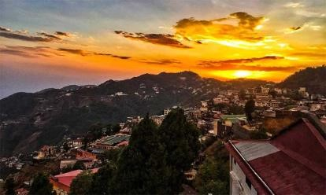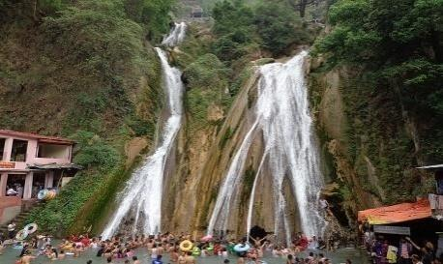
GANGOTRI- Vishwanath Temple, Bhaironghati
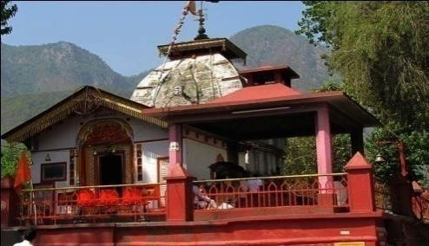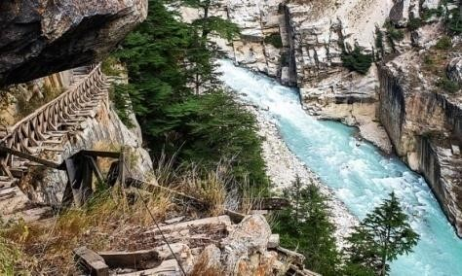
KEDARNATH- Guptkashi, Rudraprayag
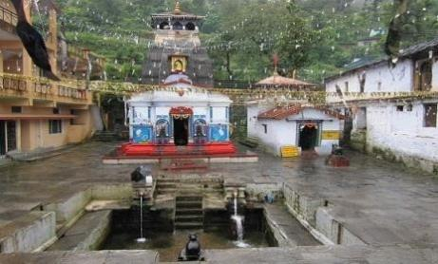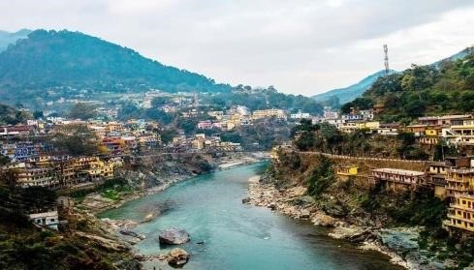
BADRINATH-Joshimath, Mana, Devprayag
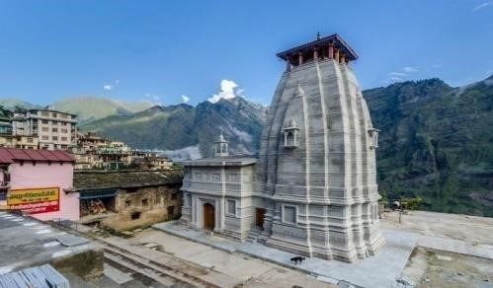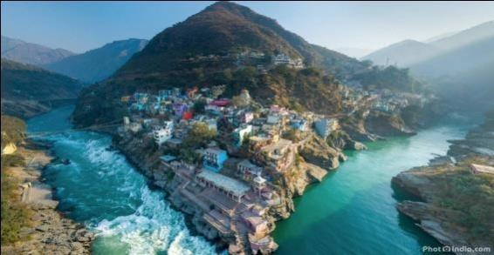

Where are the Char Dhams situated?
Char Dham Yatra comprises four holy shrines, which are located in the lap of Garhwal Himalayas in Uttarakhand. The location of pilgrimage sites are:

- Yamunotri Dham – Snuggled in Uttarkashi district of Uttarakhand at an altitude of 3,293 m above sea level, Yamunotri Dham is situated at a 190 km distance from Dehradun and 230 km away from Haridwar.

- Gangotri Dham – Perched at an altitude of 3,100 m above sea level, Gangotri temple is situated in Uttarkashi district at a distance of 285 km from Haridwar and 240 km away from Dehradun.

- Kedarnath Dham – Located in the Rudra Himalayan Ranges near Mandakini River, Kedarnath is settled amidst the mountain scape of the Rudraprayag district. From Dehradun, Kedarnath Temple is 274 km and from Haridwar, Kedarnath is around 245 km.

- Badrinath Dham – Snuggled between Nar and Narayan mountain ranges, Badrinath is situated in the Chamoli district. The distance from Badrinath is 300 km and from Haridwar and from Dehradun, Badrinath is 334 km.

PACKAGE COST INCLUDES:
- 02 night accommodation in hotel in Barkot.
- 02 night accommodation in hotel in Uttarkashi.
- 02 night accommodation in hotel in Phata.
- 01 night accommodation in hotel in Kedarnath.
- 02 night accommodation in hotel in Joshimath.
- Breakfast and Dinner.
- All transfers and sightseeing as per itinerary in Ertiga.
- All applicable fuel, toll taxes, parking fees and driver’s allowances.
PACKAGE COST DOES NOT INCLUDE:
- All personal expenses, optional tours and extra meals
- Camera fees, alcoholic/non-alcoholic beverages and starters
- Medical and travel insurance
- Room Heater Charges will be Extra in hotels

Know Before You Go for Package
- Children above 5 years of age will be considered as adults only. There are no charges for children below 5 years of age. Depends on Hotel Policy.
- All entry tickets, sightseeing, state and entry fees, monument entrances, camera charges, etc. are not a part of the tour package.
- Any personal expenses or items of personal nature will not be included in the tour package. Any meals or transfers not mentioned in the itinerary are to be considered an exclusion in the deal.
- Any kind of drink (alcoholic, aerated, or mineral water) is not included in the package
- Rates may fluctuate with any change in services/hotels. The difference in the cost shall be borne by the client in case of any amendment in the tour package due to an increase in the number of guests.
- The hotels are subject to their availability. In case, they are not available, the travellers will be accommodated in a property of similar standard.
- We reserve the right to rearrange the itinerary due to any kind of disturbance that occur/s (i.e weather conditions, political conditions or any other) without changing the total number of days and without compromising any services.
- ID proof is mandatory for each individual guest at the time of arrival.

Confirmation Policy
- The customer receives a confirmation voucher via email within 24 hours of successful booking.
- In case the preferred slots are unavailable, an alternate schedule of the customer’s preference will be arranged and a new confirmation voucher will be sent via email.
- Alternatively, the customer may choose to cancel their booking before confirmation and a full refund will be processed.

Refund Policy
- The applicable refund amount will be processed within 10 business days.
- All applicable refunds will be done on the same account from which payment had been received.
Cancellation Policy

- If cancellation are made 30 days before the date of travel then 25.0% of total tour cost will be charged as cancellation fees.
- If cancellation are made 15 days to 30 days before the date of travel then 50.0% of total tour cost will be charged as cancellation fees.
- If cancellation are made 0 days to 15 days before the date of travel then 100.0% of total tour cost will be charged as cancellation fees.
- In case of no show 100% of tour cost would be charged. No cancellation will be accepted over telephone.

Payment Terms Policy
• 100.0% of total tour cost will have to be paid 0 days before the date of booking.
STANDARD PACKAGE COST INCLUSIVE F TAXES: 31,000 PER PERSON

