EXPLORE GLOBAL (Travel with Joy)
Email: globalexplore243@gmail.com
Web site: https://Exploreglobal.in
Phone Number: 8352976379

ROYAL SHIMLA- MANALI PACKAGE FROM DELHI

Dear Sir/Madam,
Greetings from Explore Global!!!
We appreciate your query at Explore Global. We are here committed to make your holidays full of joy and hassle free indelible experience.

Details of the package Tour:-(Shimla-02,Manali-03,)5Night6 Days
1. | Tentative Travel Date | Off Season /2025
2. | Duration | 05Nights/6Days
3. | No of Persons | 4 Adults
4. | Pickup Point | Delhi
5. | Drop Point | Delhi
6. | Destination | Shimla,Kullu,Manali
7 | Vehicle offered | Dzire/Sedan/Above
8. | No. of Room | 2 Deluxe Room
9 | Meals | Breakfast & Dinner

Tour Highlights:
Day First:- Pickup Delhi Railway station /Airport and drive to Shimla .Check in hotel .Dinner and overnight stay at hotel .
Day Second:-Today morning after breakfast visit to Kufri and Mall Road sightseeing .
Day Third:-Today morning after Breakfast check out from hotel and drive to Manali on the way Kullu sightseeing
Day Fourth:- Today morning after Breakfast Visit Manali Local Sightseeing Hadimba Devi, Vashisht Village, Tibetan Monastery,Club House Etc
Day Fifth:- Today morning after Breakfast Visit Solang Valley-Atal Tunnel-Rphtang Pass .
Day Sixth:-Today morning after breakfast check out from the hotel and drive to Delhi .Tour End

HOTEL DETAILS AND PACKAGE PRICES

PACKAGE TYPE & HOTELS | Total Cost
Shimla : Aamaaz Kitchen/ Mountain Mist /Similar  Manali : Six Season Regency/White Mountain /Similar | INR:- 7,500/- Per Person Cost

DETAILED ITINERARY:-

DAY;1 DELHI TO SHIMLA

MEALS : DINNER
Pickup from Delhi Airport / Railway Station / Bus Stand by exclusive vehicle. Drive toShimla .Shimla is 350 Kilometers from Delhi and will take 08:00 -09:00 hours toreach. On arrival at Shimla. Check into the hotel. Dinner&OverNightstayinSHIMLA.

DAY2 :SHIMLA–KUFRI-SHIMLA

MEAL :BREAKFAST& DINNER

After breakfast travel towards the famous hill spot of Kufri.Get yourself free to enjoy thescenic beauty of Wild Flower Hall, Kufri. Enjoy horse riding, Yak riding(optional) inthe apple orchids, fun world Kufri, Himalayan national Park evening return to Shimla visit local and back to the hotel Dinner & Overnight Stay in Shimla.
LOCAL SIGHT SEEN OF KUFARI OR SHIMLA:
apple orchids funword Kufri
HimalayannationalParkChiniBungalowAdventureActivities.
The Ridge and The Mall Tibbetan Market
LakkarBazar
Scandal Point
Kali Baari Temple.

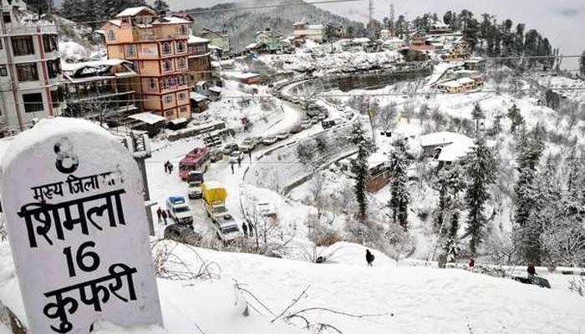

DAY 3 SHIMLA TO MANALI VIA KULLU

MEAL :BREAKFAST & DINNER
Morning checks out from the Hotel & drive to Manali (7-8 Hours), the valley of Gods, is a combination of natural splendor and rich cultural heritage. On the way stop a while at Sundar Nagar Lake, Mini Kashi Mandi ,Pandoh Dam, Hanogi Temple, Aut tunnal and Mini VeshnoDevi TempleKullu. Rest of the day at leisure.Night stay inManali.

DAY 4 MANALI SNOW POINT/SOLANG VALLEY /ATAL TUNNAL / ROHTANG PASS (EXTRA COST )
MEAL :BREAKFAST& DINNER
Enjoy the morning breakfast at the hotel and later get ready for an excursion to visit Solang, Him Valley and Nehru Kund. Solang Valley is outstandingly beautiful and isan ideal spot to view the majestic snow covered Himalayas, serene naturalsurroundings, pristine lake and fairy white snow round the year. In Solang Valleyyou can enjoy Adventure activities also i.e. PARAGLIDING, ZORBING, ROPE WAY and SKIING at owncost.Overnight stayatManali. .(Rohtang Pass only open between mid May to Mid Novmeber)
Please Note: Since the National Green Tribunal is allowing only limited vehicles to Rohtang pass per day. Rohtang pass will be subject to availability of permit from the SDM Office Manali on the spot with additional cost.
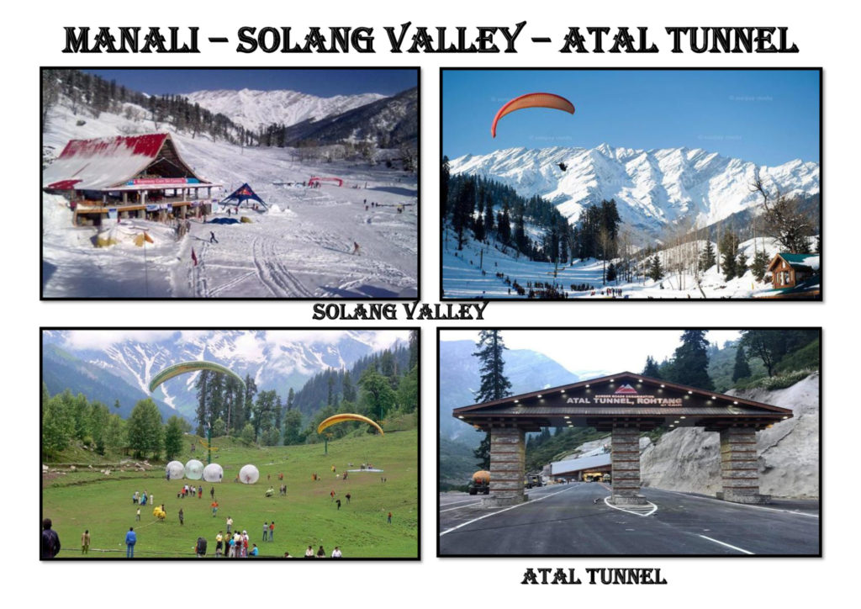

DAY 5 MANALI LOCAL SIGHTSEEING
MEAL :BREAKFAST & DINNER
Morning proceeds to Visit the 450 years old Hadimba Devi Temple built in the tranquil and serene woods, the oldest temple in Manali, Tibetan center & monastery, Club House, Van vihar, Vashisht Temple and Mall Road Manali. Night stay in Manali.
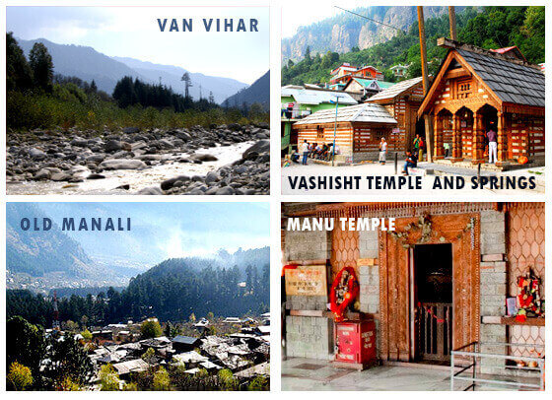
Day 06 ; DELHI DEPARTURE
Meals : Breakfast
Early Morning after breakfast checkout from hotel & Drive to Delhi and the cab will drop you Delhi Railway Station / Bus stand / Airport.
YOU’RE TOURS END BUT SWEET MEMORIES!!!!!!!
SPECIAL INCLUSIONS:

CostIncludes | CostExcludes
Accommodation for 04 person in 02 Deluxe Room | Monument entrance fee/Camera fees  AC not work in hills Area
(Buffet system in Deluxe and luxury packages. Veg. Food. | Any personal expensive – laundry, shopping, tip etc
MAP meal plan – 05 Breakfast,05 Dinner.(Buffet system in Deluxe and luxury packages. | Airfare/Train fare/Room Heater.
Transfers & sightseeing by air-conditioned vehicle for days in Delhi to Delhi. | Any adventure activity skiing, paragliding, Horse Riding etc
Sightseeing, Pickup & Drop from Delhi by Dzire/Sedan and above. | Rohtang Paas/ Atal Tunnel
Taxes&ExpendituresIncluded(Parking,TollTax,LuxuryTax,GreenTaxFuelExp.andDriver Exp.etc.). | Room Heater
IMPORTANT NOTE:
• ALL SIGHTSEEING DEPEND ON WEATHER CONDITION
• IN WINTER SEASON DUE TO SNOWFALL IF ROAD ARE BLOCKED JEEP /SNOW VEHICLE COST WILL BE YOUR OWN/EXTRA .
• Package can be altered/change as per the customer’s requirement/ interest if possible (subject to availability)
• Check in time is 12:00 Noon/Check out time of the hotel mentioned is 10:00 AM.(Early check in is subject to availability)
• We may reschedule the sightseeing days subject to weather conditions & to ensure smooth execution of tours.
• We shall not be responsible for any cancellation of cabs or buses due to bad weather & are not liable for it.
• Though Himachal has been witnessing a huge tourist growth, the facilities available cannot be matched to those available in the Cities and other developed destinations.

PAYMENT POLICY:-
- 10,000 advance on booking

- Rest payment on Tour.
If you need additional help or have any other questions, please do not hesitate to ask and be as specific as possible
------------ Wishing You a Happy Journey !!!!! --------------
Thank you for consulting Explore Global for your trip, We hope you find all the above information in order...

